

BUS USER SUPPORT SYSTEM

DETAIL DESIGN DOCUMENT

Class Design

**Project Code: BUSS**

**Document Code: BUSS_Class_Design_v1.1_EN**

**Ha Noi, 26/06/2015**

Record of change

*A - Added M - Modified D – Deleted

|  |  |  |  |  |
| --- | --- | --- | --- | --- |
| **Effective Date** | **Changed Items** | **A* M, D** | **Change Description** | **New Version** |
| 26/06/2015 | Add new | A | Add this document | v1.0 |
| 20/08/2015 | Update | M | Update this document | v1.1 |
|  |  |  |  |  |

SIGNATURE PAGE

**ORIGINATOR:** Nguyen Thanh Nam 26/06/2015

Team Leader

**REVIEWERS:** Trinh Thi Tuyet Mai 26/06/2015

Developer

**APPROVAL:** Nguyen Van Sang 30/06/2015

Supervisor

TABLE OF CONTENTS

1 Introduction 6

1.1 Purpose 6

1.2 Definitions, Acronyms and Abbreviations 6

2 Packages 7

2.1 Account management Package 8

2.1.1 Class diagram 8

2.1.2 AccountManagementModel class 8

2.1.3 AccountManagementController 9

2.1.4 Account management Sequence Diagram 10

2.2 Common Package 11

2.2.1 Class diagram 11

2.2.2 CommonModel class 12

2.2.3 CommonController class 12

2.2.4 Sequence Diagram 12

2.3 Bus Package 13

2.3.1 Class diagram 13

2.3.2 BusModel class 14

2.3.3 BusController class 14

2.3.4 Sequence diagram 15

2.4 Path Finder Package 16

2.4.1 Class diagram 16

2.4.2 PathFinderModel class 16

2.4.3 PathFinderController class 17

2.4.4 Sequence Diagram 17

2.5 Reminder Package 19

2.5.1 Class diagram 19

2.5.2 ReminderModel class 19

2.5.3 ReminderController class 20

2.5.4 Sequence Diagram 20

2.6 Track Package 21

2.6.1 Class diagram 21

2.6.2 TrackModel class 22

2.6.3 TrackController class 22

2.6.4 Sequence Diagram 22

2.7 Favorite Package 23

2.7.1 Class diagram 23

2.7.2 FavoriteModel class 23

2.7.3 FavoriteController class 24

2.7.4 Sequence Diagram 24

3 MVC model 26

# Introduction

## Purpose

Bus user support system class design document contains descriptions of all classes of the Bus user support system. It includes:

* Class diagrams that describe the static relation of all classes in the system.

## Definitions*,* Acronyms and Abbreviations

|  |  |  |
| --- | --- | --- |
| Abbreviations | Description | Comment |
| BUSS | Bus User Support System |  |

# Packages

|  |  |  |  |
| --- | --- | --- | --- |
| No | Package | Language | Description |
| 1. 01 | activity | Java | Store all activities |
|  | adapter | Java | Store all adapters for activities |
|  | common | Java | Store all common class/object |
|  | dao | Java | Store all class which provide access to data |
|  | wsclient | Java | Store all class which work with web service |
|  | libs | Java | Store all libraries |
|  | res | XML | Store all resources (layout files, images, strings, values, colors, menu….) |

## ActivityPackage

### Bus group

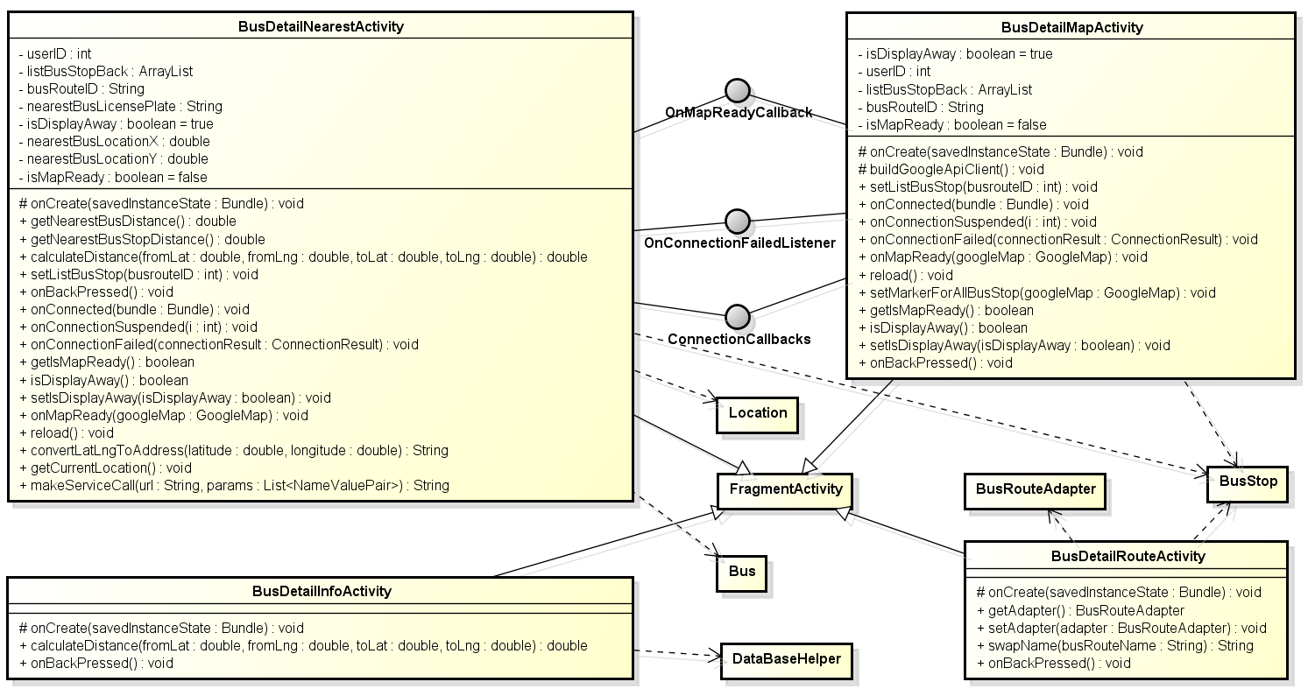

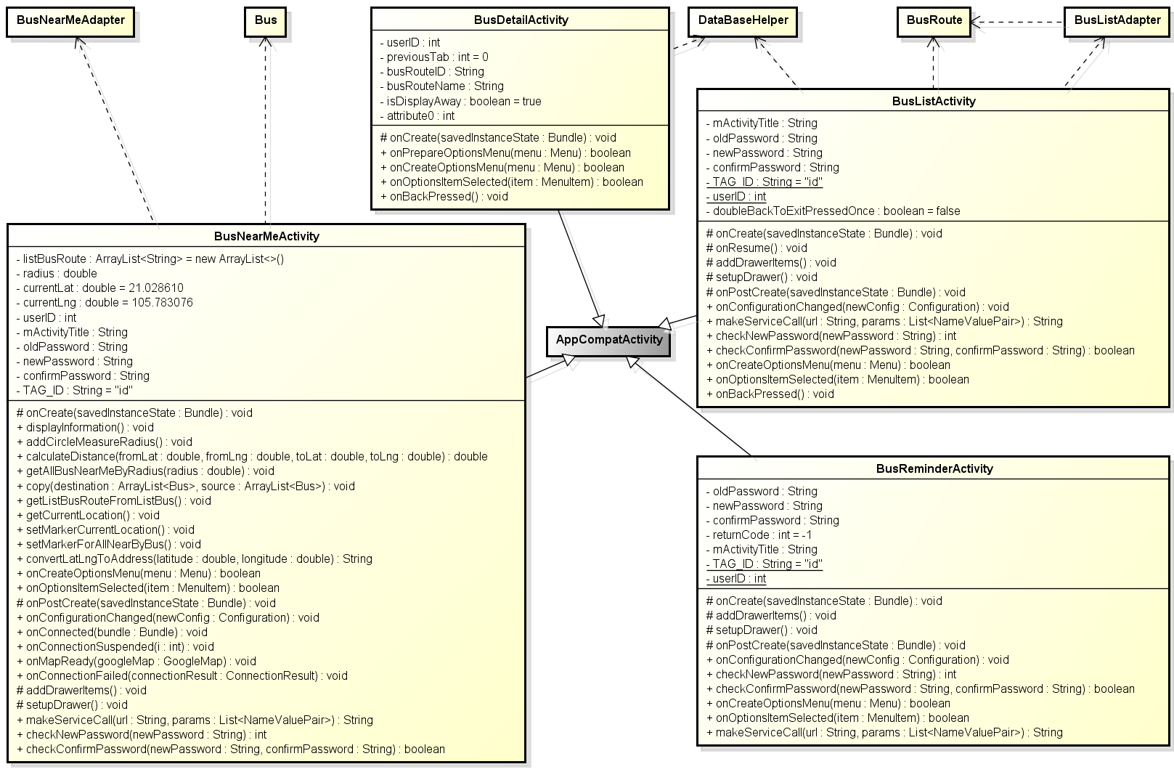

**Figure 1: Class diagram activity package – bus group**

|  |  |  |
| --- | --- | --- |
| No | Class Name | Description |
| 1 | AddFavoritePlaceActivity | Provide activity add favorite place |
| 2 | AddReminderActivity | Provide activity add reminder |
| 3 | BusDetailActivity | Provide activity bus detail |
| 4 | BusDetailInfoActivity | Provide activity bus detail tab info |
| 5 | BusDetailMapActivity | Provide activity bus detail tab map |
| 6 | BusDetailNearestActivity | Provide activity bus detail tab nearest |
| 7 | BusDetailRouteActivity | Provide activity bus detail tab route |
| 8 | BusListActivity | Provide activity bus list |
| 9 | BusNearMeActivity | Provide activity bus near me |
| 10 | DirectionActivity | Provide activity direction – navigation |
| 11 | EditFavoritePlaceActivity | Provide activity edit favorite place |
| 12 | FavoritesActivity | Provide activity favorites |
| 13 | FavoriteBusesActivity | Provide activity favorite tab bus |
| 14 | FavoritePlacesActivity | Provide activity favorite tab place |
| 15 | FindPathActivity | Provide activity find path |
| 16 | FindPathFavoriteActivity | Provide activity find path tab favorite |
| 17 | FindPathHistoryActivity | Provide activity find path tab history |
| 18 | FindPathMapActivity | Provide activity find path tab map |
| 19 | FindPlaceActivity | Provide activity find place |
| 20 | LoginActivity | Provide activity login |
| 21 | PathDetailByListActivity | Provide activity path detail by list |
| 22 | PathDetailByMapActivity | Provide activity path detail by map |
| 23 | PathFoundActivity | Provide activity path found |
| 24 | SettingsActivity | Provide activity settings |
| 25 | SignUpActivity | Provide activity sign up |
| 26 | TrackActivity | Provide activity track |

### 

#### BusDetailActivity

##### Attributes

|  |  |  |  |  |  |
| --- | --- | --- | --- | --- | --- |
| No | Attribute | Type | Default | Note | Description |
| 1 | userID | int |  | private |  |
| 2 | previousTab | int | 0 | private |  |
| 3 | busRouteID | String |  | private |  |
| 4 | busRouteName | String |  | private |  |
| 5 | isDisplayAway | boolean | true | private |  |

##### Methods

|  |  |  |
| --- | --- | --- |
| No | Method | Description |
| 1 | onCreate() | Called when activity create |
| 2 | onPrepareOptionsMenu() | Called when prepare option menu |
| 3 | onCreateOptionsMenu () | Called when create option menu |
| 4 | onOptionsItemSelected() | Called when option menu is selected |
| 5 | onBackPressed() | Called when back button is pressed |

**onCreate**

|  |  |  |  |  |  |
| --- | --- | --- | --- | --- | --- |
| No | Parameter name | Type | I/O | Default | Description |
| 1 | savedInstanceState | Bundle | In |  |  |

**onPrepareOptionsMenu**

|  |  |  |  |  |  |
| --- | --- | --- | --- | --- | --- |
| No | Parameter name | Type | I/O | Default | Description |
| 1 |  | Boolean | Out |  |  |
| 2 | menu | Menu | In |  |  |

**onCreateOptionsMenu**

|  |  |  |  |  |  |
| --- | --- | --- | --- | --- | --- |
| No | Parameter name | Type | I/O | Default | Description |
| 1 |  | Boolean | Out |  |  |
| 2 | menu | Menu | In |  |  |

**onOptionsItemSelected**

|  |  |  |  |  |  |
| --- | --- | --- | --- | --- | --- |
| No | Parameter name | Type | I/O | Default | Description |
| 1 |  | Boolean | Out |  |  |
| 2 | item | MenuItem | In |  |  |

#### BusDetailInfoActivity

##### Attributes

N/A

##### Methods

|  |  |  |
| --- | --- | --- |
| No | Method | Description |
| 1 | onCreate() | Called when activity create |
| 2 | calculateDistance() | Call to calculate distance between two LatLng point |
| 3 | onBackPressed() | Called when back button is pressed |

|  |  |  |  |
| --- | --- | --- | --- |
|  | | | |
| * **Return:** * **Visibility:** * **Purpose:** | | | |
| Parameters | | | |
| No. | Parameter | Type | Description |

|  |  |  |  |
| --- | --- | --- | --- |
|  |  |  |  |

|  |  |  |  |
| --- | --- | --- | --- |
| onCreate() | | | |
| * **Return:** void * **Visibility:** protected * **Purpose:** create activity | | | |
| Parameters | | | |
| No. | Parameter | Type | Description |

|  |  |  |  |
| --- | --- | --- | --- |
| 1 | saveInstanceState | Bundle |  |

|  |  |  |  |
| --- | --- | --- | --- |
| calculateDistance() | | | |
| * **Return:** double * **Visibility:** public * **Purpose:** calculate distance between two latlng | | | |
| Parameters | | | |
| No. | Parameter | Type | Description |

|  |  |  |  |
| --- | --- | --- | --- |
| 1 | fromLat | Double | From point’s latitude |
| 2 | toLat | Double | From point’s longitude |
| 3 | fromLng | Double | To point’s latitude |
| 4 | toLng | Double | To point’s longitude |

|  |
| --- |
| onBackPressed() |
| * **Return:** void * **Visibility:** public * **Purpose:** handle when back button is pressed |

#### BusDetailMapActivity

##### Attributes

|  |  |  |  |  |  |
| --- | --- | --- | --- | --- | --- |
| No | Attribute | Type | Default | Note | Description |
| 1 | isDisplayAway | boolean | True | private |  |
| 2 | userID | int | 0 | private |  |
| 3 | listBusStopBack | ArrayList<BusStop> |  | private |  |
| 4 | busRouteID | String |  | private |  |
| 5 | isMapReady | boolean | false | private |  |

##### Methods

|  |
| --- |
| buildGoogleApiClient() |
| * **Return:** void * **Visibility:** protected * **Purpose:** build api client |
| Parameters |

|  |  |  |  |
| --- | --- | --- | --- |
| onCreate() | | | |
| * **Return:** void * **Visibility:** protected * **Purpose:** create activity | | | |
| Parameters | | | |
| No. | Parameter | Type | Description |

|  |  |  |  |
| --- | --- | --- | --- |
| 1 | saveInstanceState | Bundle |  |

|  |  |  |  |
| --- | --- | --- | --- |
| setListBusStop() | | | |
| * **Return:** void * **Visibility:** public * **Purpose:** set list bus stop | | | |
| Parameters | | | |
| No. | Parameter | Type | Description |

|  |  |  |  |
| --- | --- | --- | --- |
| 1 | busrouteID | Int | Bus route id |

|  |
| --- |
| onBackPressed() |
| * **Return:** void * **Visibility:** public * **Purpose:** handle when back button is pressed |

|  |
| --- |
| onConnected() |
| * **Return:** void * **Visibility:** public * **Purpose:** called when connected |

|  |  |  |  |
| --- | --- | --- | --- |
| onConnectionSuspended() | | | |
| * **Return:** void * **Visibility:** public * **Purpose:** called when connection suspended | | | |
| Parameters | | | |
| No. | Parameter | Type | Description |

|  |  |  |  |
| --- | --- | --- | --- |
| 1 | i | Int |  |

|  |  |  |  |
| --- | --- | --- | --- |
| onConnectionFailed() | | | |
| * **Return:** void * **Visibility:** public * **Purpose:** called when connect failed | | | |
| Parameters | | | |
| No. | Parameter | Type | Description |

|  |  |  |  |
| --- | --- | --- | --- |
| 1 | connectionResult | ConnectionResult | Bus route id |

|  |
| --- |
| onMapReady() |
| * **Return:** void * **Visibility:** public * **Purpose:** called when map ready |

|  |
| --- |
| reload() |
| * **Return:** void * **Visibility:** public * **Purpose:** called when activity reload |

|  |  |  |  |
| --- | --- | --- | --- |
| setMarkerForAllBusStop() | | | |
| * **Return:** void * **Visibility:** public * **Purpose:** called when app content reconnect | | | |
| Parameters | | | |
| No. | Parameter | Type | Description |

|  |  |  |  |
| --- | --- | --- | --- |
| 1 | busrouteID | Int | Bus route id |
| 2 | googleMap | GoogleMap | Map to handle things |

|  |
| --- |
| getIsMapReady() |
| * **Return:** void * **Visibility:** public * **Purpose:** called when app content reconnect |

|  |
| --- |
| isDisplayAway() |
| * **Return:** void * **Visibility:** public * **Purpose:** called when app content reconnect |

|  |  |  |  |
| --- | --- | --- | --- |
| setIsDisplayAway() | | | |
| * **Return:** void * **Visibility:** public * **Purpose:** called when app content reconnect | | | |
| Parameters | | | |
| No. | Parameter | Type | Description |

|  |  |  |  |
| --- | --- | --- | --- |
| 1 | isDisplayAway | Int | Parameter indicate is display away or not |

|  |
| --- |
| onBackPressed() |
| * **Return:** void * **Visibility:** public * **Purpose:** handle when back button is pressed |

#### BusDetailNearestActivity

##### Attributes

|  |  |  |  |  |  |
| --- | --- | --- | --- | --- | --- |
| No | Attribute | Type | Default | Note | Description |
| 1 | isDisplayAway | boolean | True | private |  |
| 2 | nearestBusLicensePlate | String |  | private |  |
| 3 | listBusStopBack | ArrayList<BusStop> |  | private |  |
| 4 | busRouteID | String |  | private |  |
| 5 | isMapReady | boolean | false | private |  |
| 6 | nearestBusLocationX | Double |  | private |  |
| 7 | nearestBusLocationY | double |  | private |  |
| 8 | userID | Int | 0 | private |  |

##### Methods

|  |
| --- |
| getNearestBusDistance() |
| * **Return:** double * **Visibility:** public * **Purpose:** get nearest bus distance |
| Parameters |

|  |
| --- |
| getNearestBusStopDistance() |
| * **Return:** double * **Visibility:** public * **Purpose:** get nearest bus stop distance |
| Parameters |

|  |  |  |  |
| --- | --- | --- | --- |
| setListBusStop() | | | |
| * **Return:** void * **Visibility:** public * **Purpose:** set list bus stop | | | |
| Parameters | | | |
| No. | Parameter | Type | Description |

|  |  |  |  |
| --- | --- | --- | --- |
| 1 | busrouteID | Int | Bus route id |

|  |  |  |  |
| --- | --- | --- | --- |
| calculateDistance() | | | |
| * **Return:** double * **Visibility:** public * **Purpose:** calculate distance between two latlng | | | |
| Parameters | | | |
| No. | Parameter | Type | Description |

|  |  |  |  |
| --- | --- | --- | --- |
| 1 | fromLat | Double | From point’s latitude |
| 2 | toLat | Double | From point’s longitude |
| 3 | fromLng | Double | To point’s latitude |
| 4 | toLng | Double | To point’s longitude |

|  |
| --- |
| reload() |
| * **Return:** void * **Visibility:** public * **Purpose:** called when activity reload |

|  |  |  |  |
| --- | --- | --- | --- |
| onCreate() | | | |
| * **Return:** void * **Visibility:** protected * **Purpose:** create activity | | | |
| Parameters | | | |
| No. | Parameter | Type | Description |

|  |  |  |  |
| --- | --- | --- | --- |
| 1 | saveInstanceState | Bundle |  |

|  |
| --- |
| onConnected() |
| * **Return:** void * **Visibility:** public * **Purpose:** called when connected |

|  |  |  |  |
| --- | --- | --- | --- |
| onConnectionSuspended() | | | |
| * **Return:** void * **Visibility:** public * **Purpose:** called when connection suspended | | | |
| Parameters | | | |
| No. | Parameter | Type | Description |

|  |  |  |  |
| --- | --- | --- | --- |
| 1 | i | Int |  |

|  |  |  |  |
| --- | --- | --- | --- |
| onConnectionFailed() | | | |
| * **Return:** void * **Visibility:** public * **Purpose:** called when connect failed | | | |
| Parameters | | | |
| No. | Parameter | Type | Description |

|  |  |  |  |
| --- | --- | --- | --- |
| 1 | connectionResult | ConnectionResult | Bus route id |

|  |
| --- |
| onMapReady() |
| * **Return:** void * **Visibility:** public * **Purpose:** called when map ready |

|  |
| --- |
| getIsMapReady() |
| * **Return:** void * **Visibility:** public * **Purpose:** called when app content reconnect |

|  |
| --- |
| isDisplayAway() |
| * **Return:** void * **Visibility:** public * **Purpose:** called when app content reconnect |

|  |  |  |  |
| --- | --- | --- | --- |
| setIsDisplayAway() | | | |
| * **Return:** void * **Visibility:** public * **Purpose:** called when app content reconnect | | | |
| Parameters | | | |
| No. | Parameter | Type | Description |

|  |  |  |  |
| --- | --- | --- | --- |
| 1 | isDisplayAway | Int | Parameter indicate is display away or not |

|  |
| --- |
| onBackPressed() |
| * **Return:** void * **Visibility:** public * **Purpose:** handle when back button is pressed |

|  |
| --- |
| getCurrentLocation() |
| * **Return:** void * **Visibility:** public * **Purpose:** called to get current location |
| Parameters |

|  |  |  |  |
| --- | --- | --- | --- |
| convertLatLngToAddress() | | | |
| * **Return:** String * **Visibility:** public * **Purpose:** called to convert latlng to address | | | |
| Parameters | | | |
| No. | Parameter | Type | Description |

|  |  |  |  |
| --- | --- | --- | --- |
| 1 | Lat | Double |  |
| 2 | Lng | Double |  |

|  |  |  |  |
| --- | --- | --- | --- |
| makeServiceCall() | | | |
| * **Return:** String * **Visibility:** public * **Purpose:** called to convert latlng to address | | | |
| Parameters | | | |
| No. | Parameter | Type | Description |

|  |  |  |  |
| --- | --- | --- | --- |
| 1 | url | String |  |
| 2 | params | List<NameValuePair> |  |

#### BusDetailRouteActivity

##### Attributes

N/A

##### Methods

|  |  |  |  |
| --- | --- | --- | --- |
| onCreate() | | | |
| * **Return:** void * **Visibility:** protected * **Purpose:** create activity | | | |
| Parameters | | | |
| **No.** | **Parameter** | **Type** | **Description** |
| 1 | saveInstanceState | Bundle |  |

|  |
| --- |
| getAdapter() |
| * **Return:** BusRouteAdapter * **Visibility:** public * **Purpose:** get adapter |

|  |  |  |  |
| --- | --- | --- | --- |
| setAdapter() | | | |
| * **Return:** void * **Visibility:** protected * **Purpose:** set adapter | | | |
| Parameters | | | |
| **No.** | **Parameter** | **Type** | **Description** |
| 1 | adapter | BusRouteAdapter | Adapter of BusRoute |

|  |  |  |  |
| --- | --- | --- | --- |
| swapName() | | | |
| * **Return:** String * **Visibility:** public * **Purpose:** swap bus direction | | | |
| Parameters | | | |
| **No.** | **Parameter** | **Type** | **Description** |
| 1 | busRouteName | String | Bus route name |

|  |
| --- |
| onBackPressed() |
| * **Return:** void * **Visibility:** public * **Purpose:** Handle onBackPressed event |

#### BusListActivity

##### Attributes

|  |  |  |  |  |  |
| --- | --- | --- | --- | --- | --- |
| No | Attribute | Type | Default | Note | Description |
| 1 | mActivityTitle | String |  | private |  |
| 2 | oldPassword | String |  | private |  |
| 3 | newPassword | String |  | private |  |
| 4 | confirmPassword | String |  | private |  |
| 5 | TAG_ID | String | id | private |  |
| 6 | userID | int |  | private |  |
| 7 | doubleBackToExitPressedOnce | boolean | false | private |  |

##### Methods

|  |  |  |  |
| --- | --- | --- | --- |
| onCreate() | | | |
| * **Return:** void * **Visibility:** protected * **Purpose:** create activity | | | |
| Parameters | | | |
| **No.** | **Parameter** | **Type** | **Description** |
| 1 | saveInstanceState | Bundle | Save instance state |

|  |
| --- |
| onResume() |
| * **Return:** void * **Visibility:** protected * **Purpose:** call when activity is on resume |

|  |
| --- |
| addDrawerItems() |
| * **Return:** void * **Visibility:** protected * **Purpose:** add drawer item |

|  |
| --- |
| setupDrawer() |
| * **Return:** void * **Visibility:** protected * **Purpose:** setup drawer |

|  |  |  |  |
| --- | --- | --- | --- |
| onPostCreate() | | | |
| * **Return:** void * **Visibility:** protected * **Purpose:** call before starting activity | | | |
| Parameters | | | |
| **No.** | **Parameter** | **Type** | **Description** |
| 1 | savedInstanceState | Bundle | Save instance state |

|  |  |  |  |
| --- | --- | --- | --- |
| onConfigurationChanged() | | | |
| * **Return:** void * **Visibility:** public * **Purpose:** call when configuration was changed | | | |
| Parameters | | | |
| **No.** | **Parameter** | **Type** | **Description** |
| 1 | newConfig | Configuration |  |

|  |  |  |  |
| --- | --- | --- | --- |
| makeServiceCall() | | | |
| * **Return:** String * **Visibility:** public * **Purpose:** | | | |
| Parameters | | | |
| **No.** | **Parameter** | **Type** | **Description** |
| 1 | url | String |  |
| 2 | params | List<NameValuePair> |  |

|  |  |  |  |
| --- | --- | --- | --- |
| checkNewPassword() | | | |
| * **Return:** int * **Visibility:** public * **Purpose:** check new password field | | | |
| Parameters | | | |
| **No.** | **Parameter** | **Type** | **Description** |
| 1 | newPassword | String |  |

|  |  |  |  |
| --- | --- | --- | --- |
| checkConfirmPassword() | | | |
| * **Return:** boolean * **Visibility:** public * **Purpose:** check confirm password field | | | |
| Parameters | | | |
| **No.** | **Parameter** | **Type** | **Description** |
| 1 | newPassword | String |  |
| 2 | confirmPassword | String |  |

|  |  |  |  |
| --- | --- | --- | --- |
| onCreateOptionsMenu() | | | |
| * **Return:** boolean * **Visibility:** public * **Purpose:** call when create menu | | | |
| Parameters | | | |
| **No.** | **Parameter** | **Type** | **Description** |
| 1 | item | MenuItem |  |

|  |  |  |  |
| --- | --- | --- | --- |
| onOptionsItemSelected() | | | |
| * **Return:** double * **Visibility:** public * **Purpose:** get nearest bus distance | | | |
| Parameters | | | |
| **No.** | **Parameter** | **Type** | **Description** |
|  |  |  |  |

|  |
| --- |
| onBackPressed() |
| * **Return:** void * **Visibility:** public * **Purpose:** Handle onBackPressed event |

#### BusNearMeActivity

### Path group

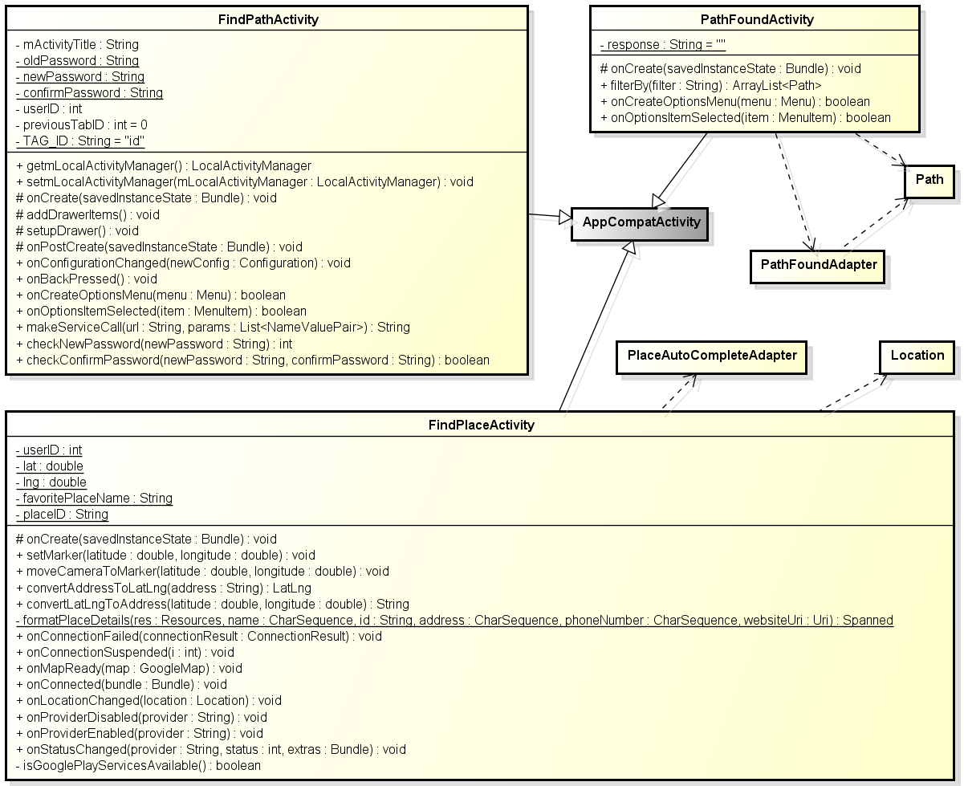

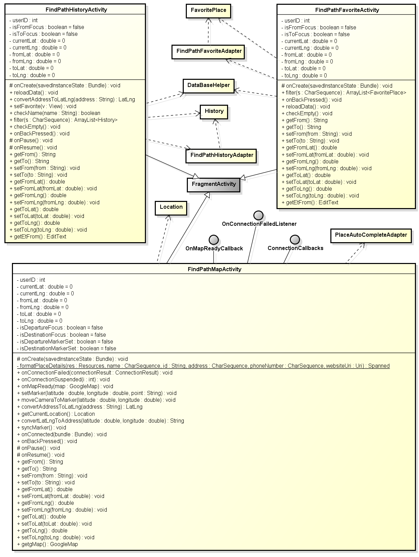

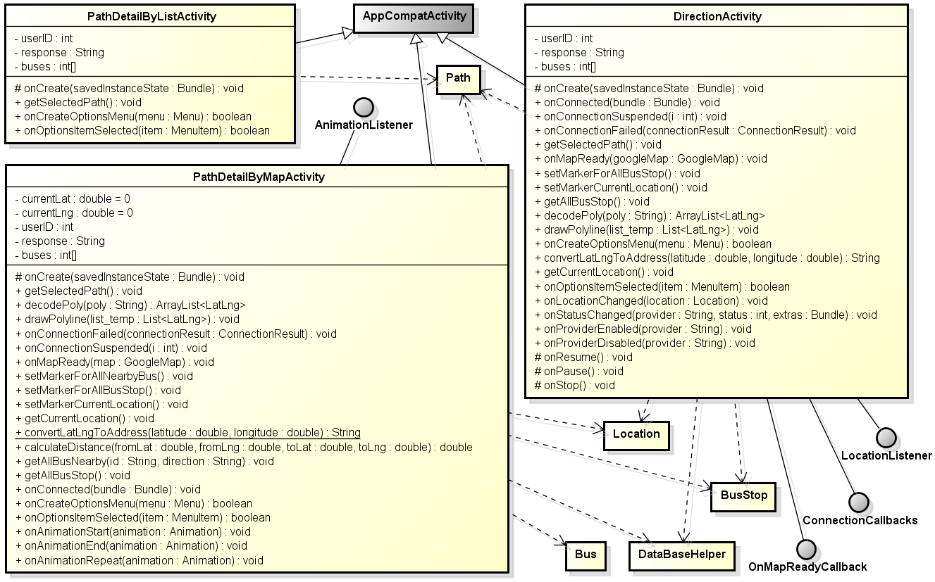

#### FindPathActivity

#### FindPathMapActivity

#### FindPathHistoryActivity

#### FindPathFavoriteActivity

#### FindPlaceActivity

#### PathFoundActivity

#### PathDetailByListActivity

#### PathDetailByMapActivity

#### DirectionActivity

### Favorites group

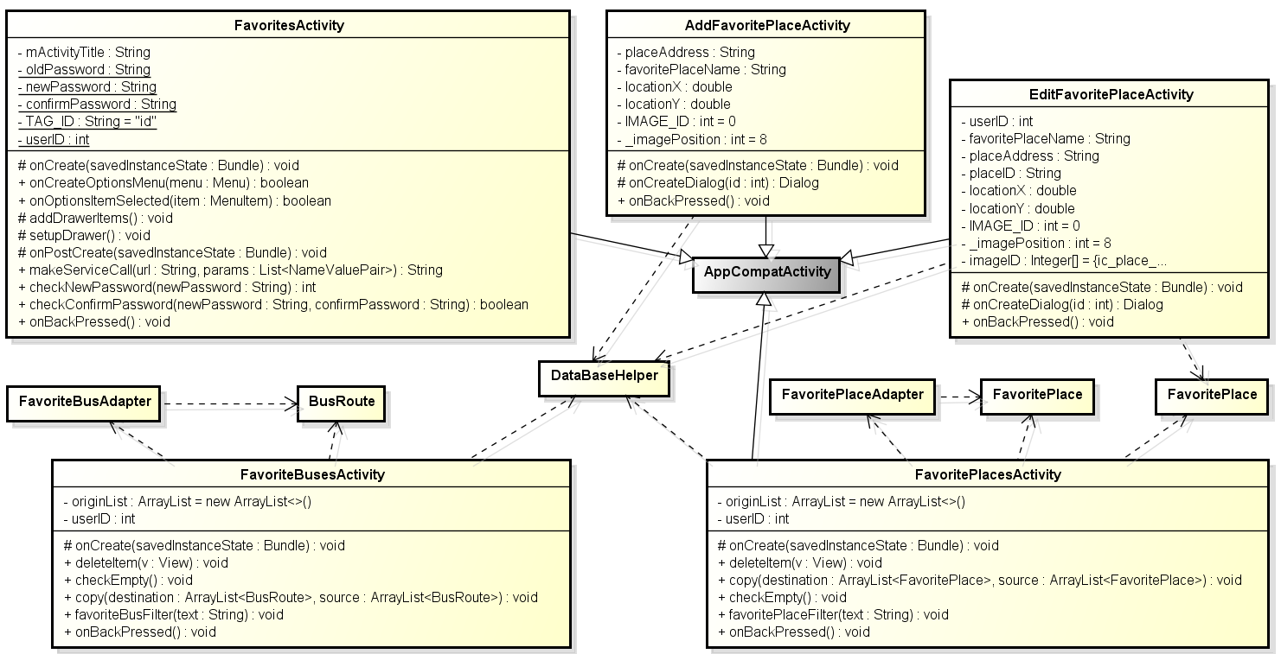

#### FavoritesActivity

#### FavoriteBusesActivity

#### FavoritePlacesActivity

#### AddFavoritePlaceActivity class

##### Attributes

|  |  |  |  |  |  |
| --- | --- | --- | --- | --- | --- |
| No | Attribute | Type | Default | Note | Description |
| 1. 1 | _imagePosition | Int | 8 | private |  |
| 1. 2 | actionMode | ActionMode |  | Private |  |
| 1. 3 | btChooseIcon | ImageButton |  | Private |  |
|  | callback | ActionMode.CallBack |  | Private |  |
|  | dialog | Dialog |  | Private |  |
|  | favoritePlace | FavoritePlace |  | Private |  |
|  | favoritePlaceName | String |  | Private |  |
|  | IMAGE_ID | Int | 0 | Private |  |
|  | ivPlaceIcon | ImageView |  | Private |  |
|  | locationX | Double |  | Private |  |
|  | location | Double |  | Private |  |
|  | placeAddress | String |  | Private |  |

##### Methods

|  |  |  |
| --- | --- | --- |
| No | Method | Description |
|  | onBackPressed() | Handle onBackPressed event |
|  | onCreate(Bundle) | Called when activity create |
|  | onCreateDialog(int) | Called when create dialog |

**onCreate**

|  |  |  |  |  |  |
| --- | --- | --- | --- | --- | --- |
| No | Parameter name | Type | I/O | Default | Description |
| 1 | savedInstanceState | Bundle | In |  |  |

**onCreateDialog**

|  |  |  |  |  |  |
| --- | --- | --- | --- | --- | --- |
| No | Parameter name | Type | I/O | Default | Description |
| 1 | Id | int | In |  |  |
| 2 | Dialog | Dialog | Out |  |  |

#### EditFavoritePlaceActivity

### Reminder group

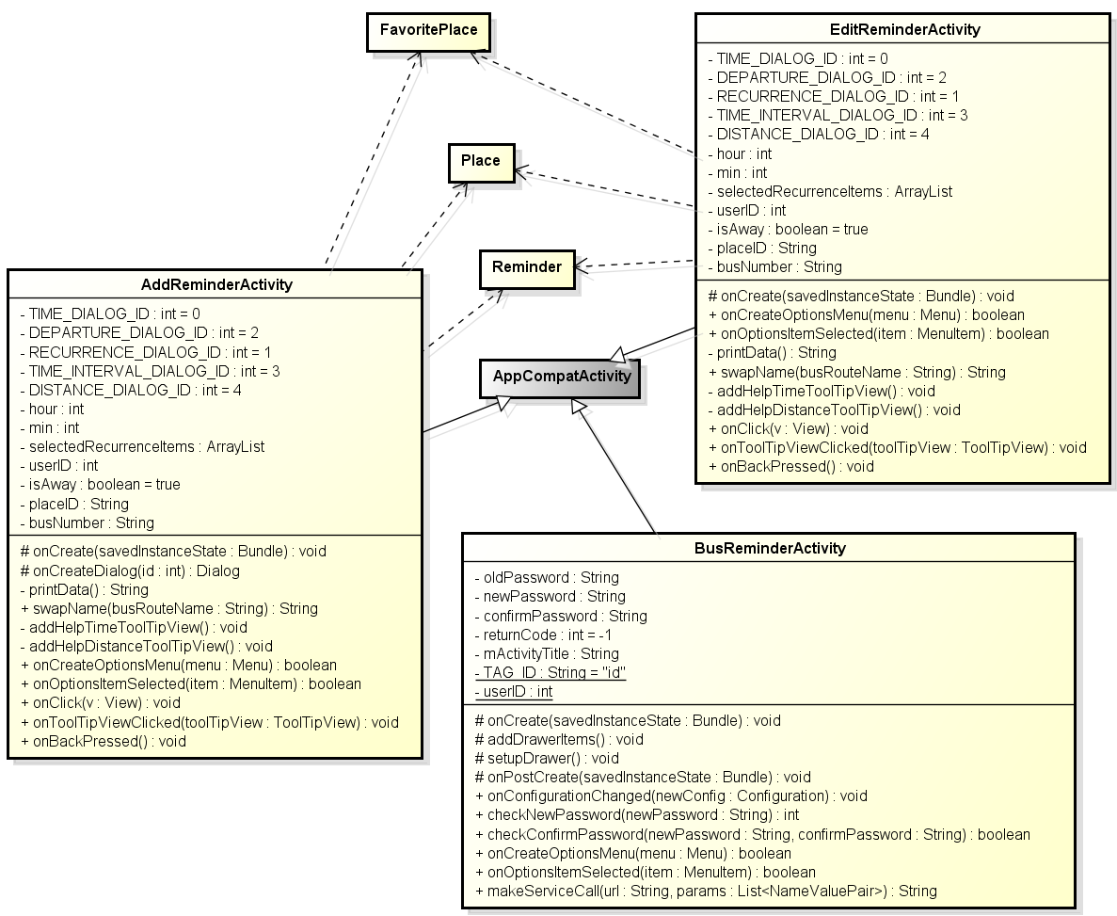

#### BusReminderActivity

##### Attributes

##### Methods

#### AddReminderActivity

##### Attributes

##### Methods

#### EditReminderActivity

##### Attributes

##### Methods

### Other

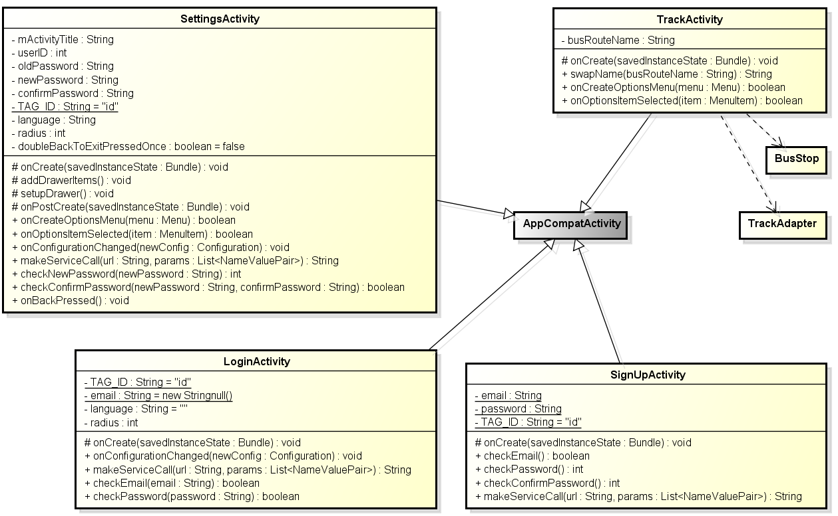

#### LoginActivity

##### Attributes

##### Methods

#### SignUpActivity

##### Attributes

##### Methods

#### SettingsActivity

##### Attributes

##### Methods

#### TrackActivity

##### Attributes

##### Methods

## AdapterPackage

### Class diagram

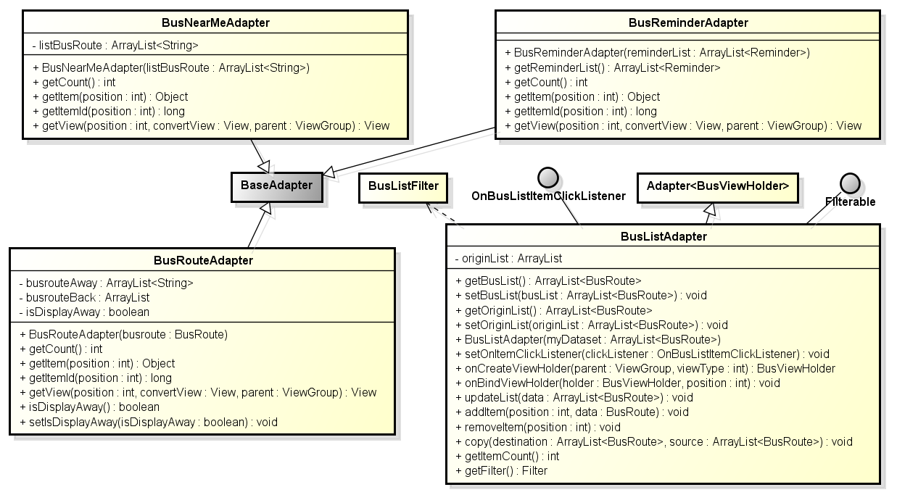

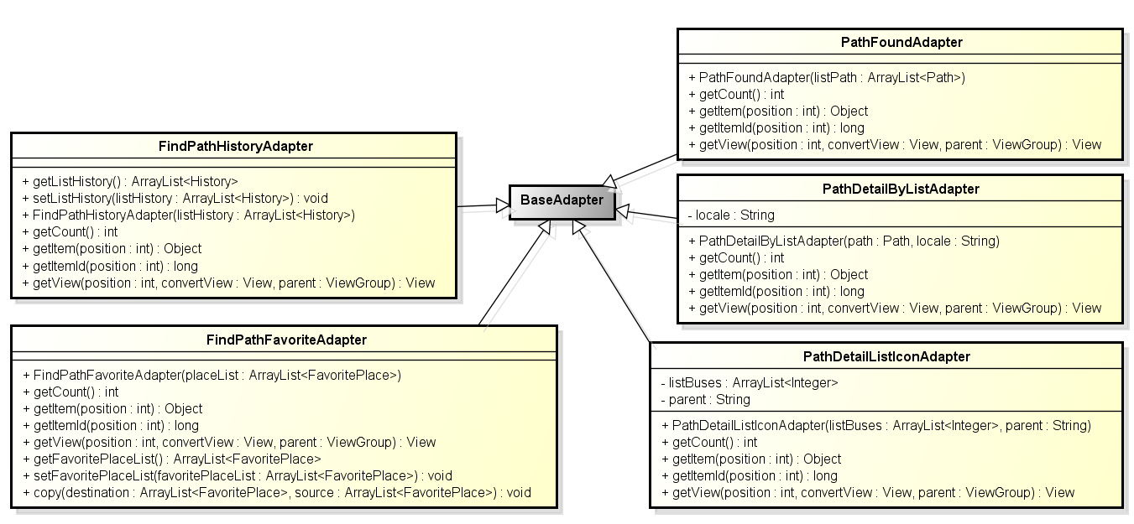

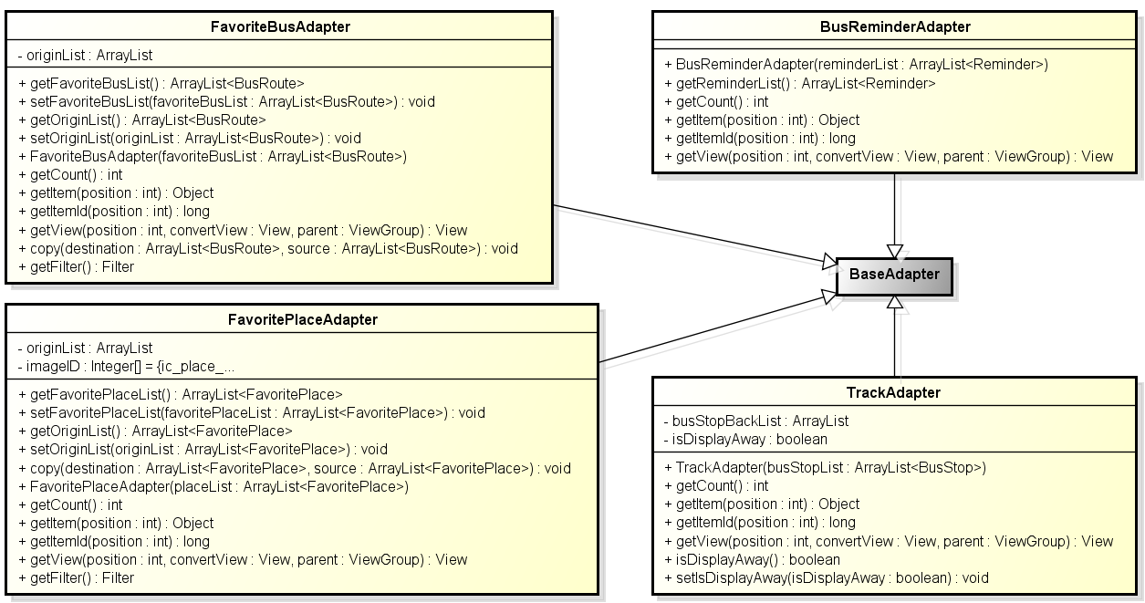

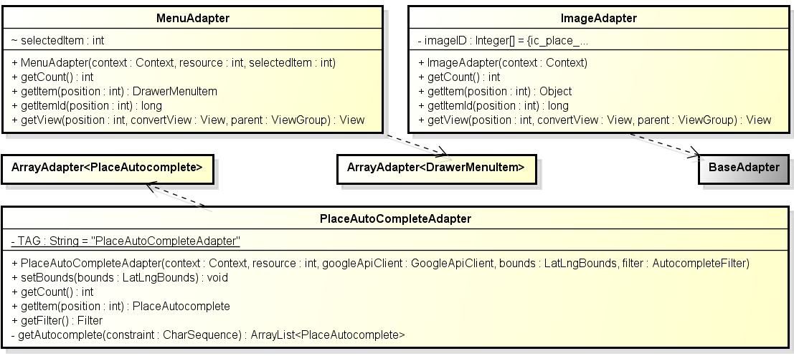

**Figure 2: Class diagram adapter package**

|  |  |  |
| --- | --- | --- |
| No | Class Name | Description |
| 1 | BusListAdapter |  |
| 2 | BusNearMeAdapter |  |
| 3 | BusReminderAdapter |  |
| 4 | BusRouteAdapter |  |
| 5 | FavoriteBusAdapter |  |
| 6 | FavoritePlaceAdapter |  |
| 7 | FindPathFavoriteAdapter |  |
| 8 | FindPathHistoryAdapter |  |
| 9 | ImageAdapter |  |
| 10 | MenuAdapter |  |
| 11 | PathDetailByListAdapter |  |
| 12 | PathDetailListIconAdapter |  |
| 13 | PathFoundAdapter |  |
| 14 | PlaceAutoCompleteAdapter |  |
| 15 | TrackAdapter |  |

### BusListAdapter

#### Attributes

|  |  |  |  |  |  |
| --- | --- | --- | --- | --- | --- |
| No | Attribute | Type | Default | Note | Description |
| 1 | language | String |  | Package |  |
| 2 | searchradius | Number |  | Package |  |

#### Methods

|  |  |  |
| --- | --- | --- |
| No | Method | Description |
|  | getLanguage() | Interact with database: get language info |
|  | getSearchRadius() | Interact with database: get search radius info |
|  | setLanguage() | Interact with database: set language |
|  | setSearchRadius() | Interact with database: set search radius |

### BusNearMeAdapter

#### Attributes

|  |  |  |  |  |  |
| --- | --- | --- | --- | --- | --- |
| No | Attribute | Type | Default | Note | Description |

#### Methods

|  |  |  |
| --- | --- | --- |
| No | Method | Description |
|  | setting(String) | Set language |
|  | setting(int) | Set search radius |

### BusRouteAdapter

### FavoriteBusAdapter

### FavoritePlaceAdapter

### FindPathFavoriteAdapter

### FindPathHistoryAdapter

### ImageAdapter

### MenuAdapter

### PathDetailByListAdapter

### PathDeatilListIconAdapter

### PathFoundAdapter

### PlaceAutoCompleteAdapter

### TrackAdapter

### Sequence Diagram

#### UC006_Change app setting

## Common Package

### Class diagram

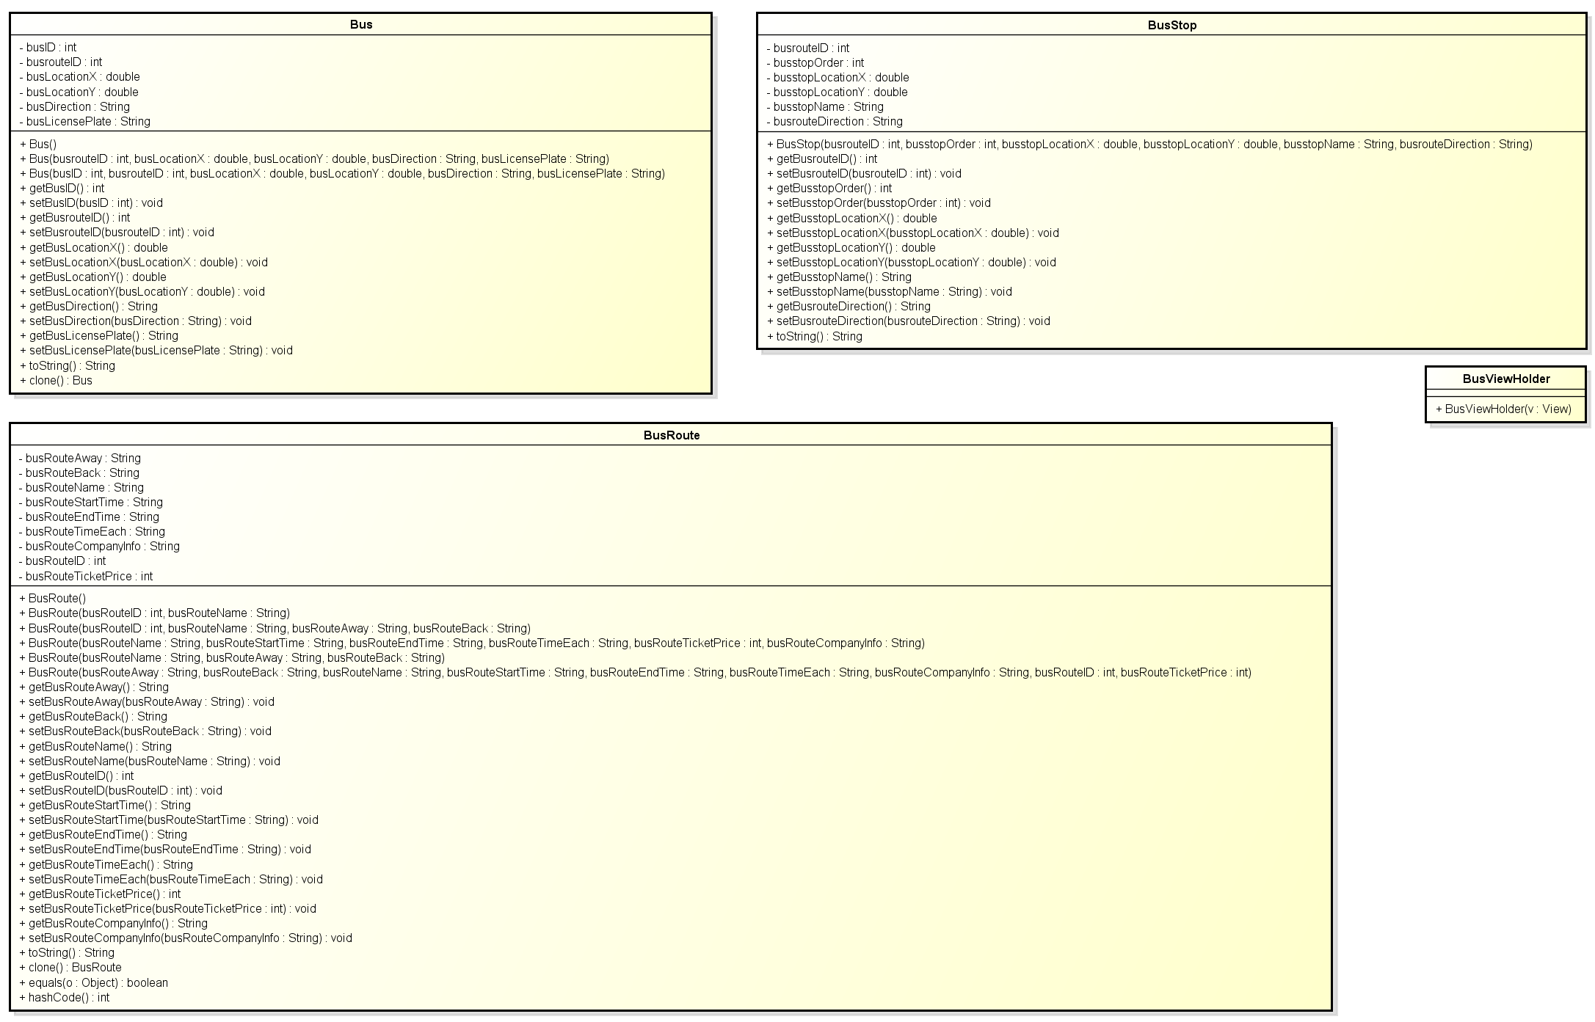

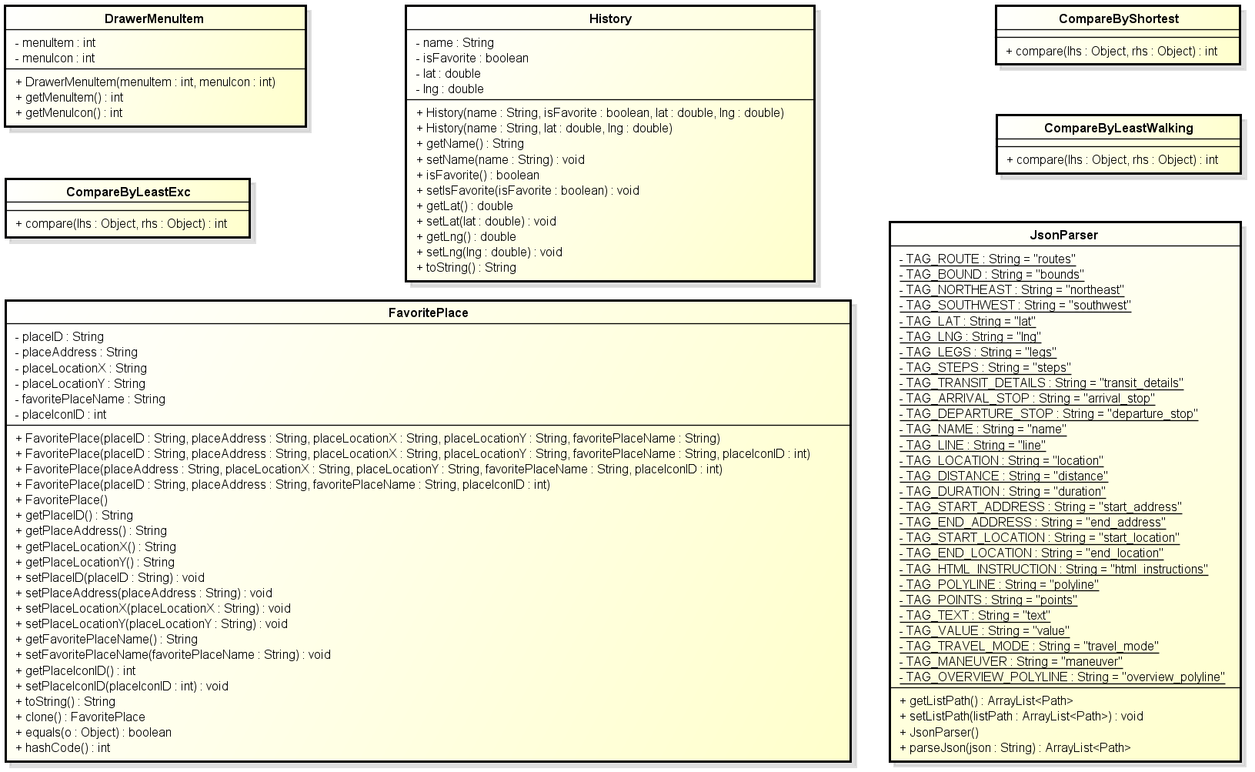

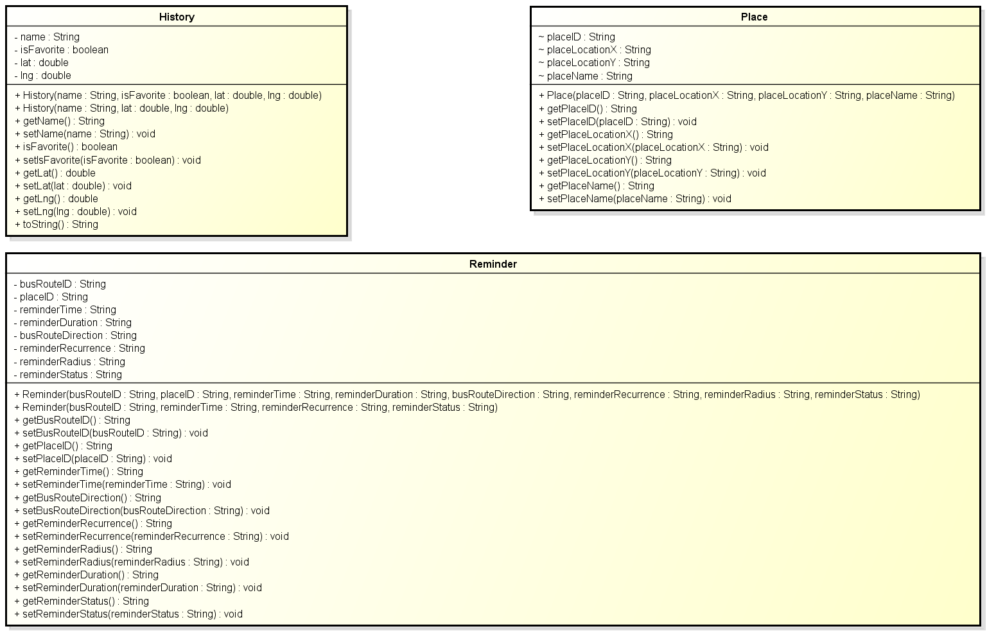

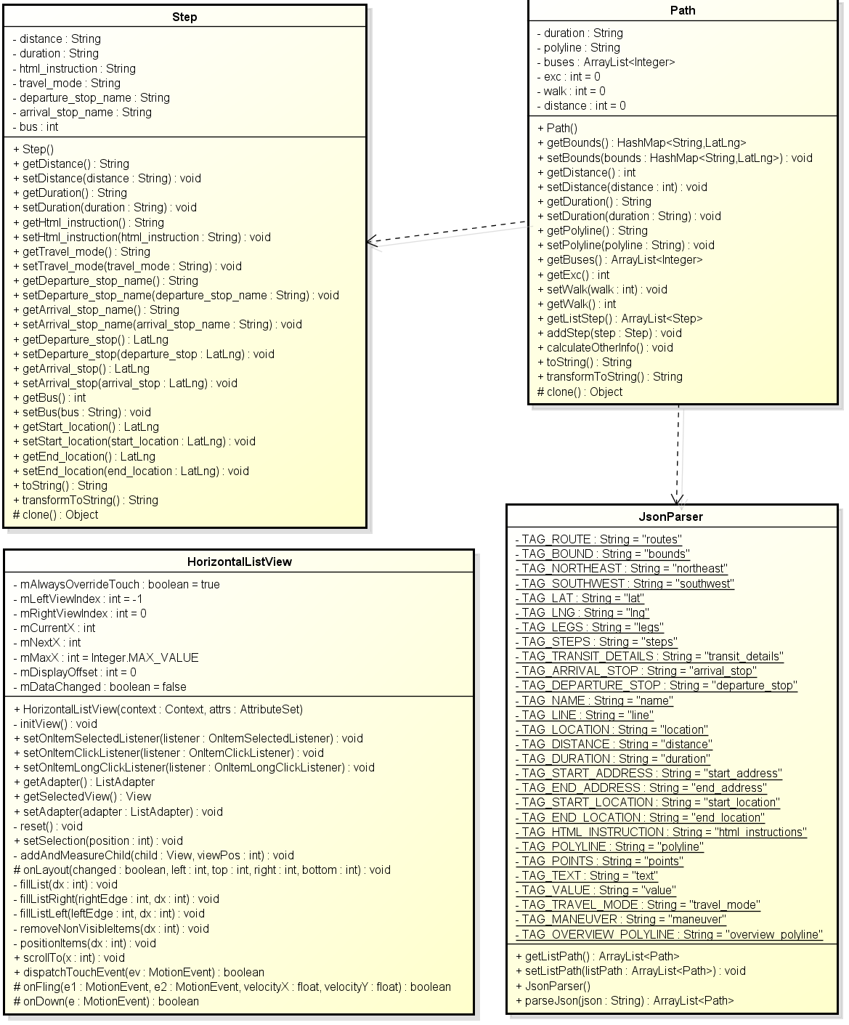

**Figure 3: Class diagram Common package**

|  |  |  |
| --- | --- | --- |
| No | Class Name | Description |
| 1 | Bus |  |
| 2 | BusRoute |  |
| 3 | BusStop |  |
| 4 | BusViewHolder |  |
| 5 | CompareByLeastExc |  |
| 6 | CompareByLeastWalking |  |
| 7 | CompareByShortest |  |
| 8 | DrawerMenuItem |  |
| 9 | FavoritePlace |  |
| 10 | History |  |
| 11 | HorizontalListView |  |
| 12 | JsonParser |  |
| 13 | Path |  |
| 14 | Place |  |
| 15 | Reminder |  |
| 16 | Step |  |

### Bus

#### Attributes

|  |  |  |  |  |  |
| --- | --- | --- | --- | --- | --- |
| No | Attribute | Type | Default | Note | Description |
| 1 | busList | Bus[] |  | package |  |

#### Methods

|  |  |  |
| --- | --- | --- |
| No | Method | Description |
|  |  |  |
|  |  |  |
|  |  |  |
|  |  |  |
|  |  |  |
|  |  |  |
|  |  |  |
|  |  |  |

### BusRoute

#### Attributes

|  |  |  |  |  |  |
| --- | --- | --- | --- | --- | --- |
| No | Attribute | Type | Default | Note | Description |

#### Methods

|  |  |  |
| --- | --- | --- |
| No | Method | Description |
|  | viewBusList() | View bus list |
|  | viewBusDetail() | View bus detail |
|  | viewBusRoute() | View bus route |
|  | viewBusMap() | View bus map |
|  | viewBusNearest() | View bus nearest |
|  | viewBusNearMe() | View bus near me |

### BusStop

### BusViewHolder

### CompareByLeastExc

### CompareByLeastWalking

### CompareByShortest

### DrawerMenuItem

### FavoritePlace

### History

### HorizontalListView

### JsonParser

### Path

### Place

### Place

### Reminder

### Step

### Sequence diagram

#### UC0007_View bus list

#### UC0008_Search bus in list

#### UC0009_View bus info

#### UC0010_View bus route

#### UC0011_View bus map

#### UC0012_View bus nearest

#### UC0013_View bus near me

## dao Package

### Class diagram

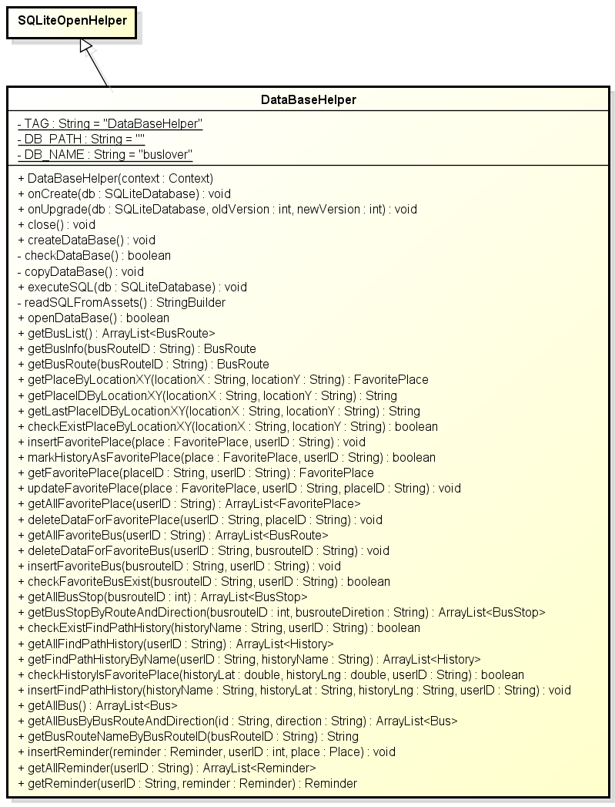

***Figure 4: Class diagram dao package***

|  |  |  |
| --- | --- | --- |
| No | Class Name | Description |
| 1 | DataBaseHelper | Include method interact with database |

### DataBaseHelper

#### Attributes

|  |  |  |  |  |  |
| --- | --- | --- | --- | --- | --- |
| No | Attribute | Type | Default | Note | Description |
| 1. 1 | departure | Place |  | private |  |
| 1. 2 | destination | Place |  | private |  |
| 1. 3 | pathList | Path[] |  | private |  |

#### Methods

|  |  |  |
| --- | --- | --- |
| No | Method | Description |
|  | findPath() | Find path |
|  | getDeparture() | Get departure |
|  | getDestination() | Get destination |
|  | setDeparture() | Set departure |
|  | setDestination() | Set destination |
|  | showPathFound() | Show path found |
|  | showPathDetail() | Show path detail |
|  | showDirection() | Show direction |

### Sequence Diagram

#### UC0014_Find path

#### UC0015_View path found

#### UC0016_View path detail

#### UC0017_View direction

## wsclient Package

### Class diagram

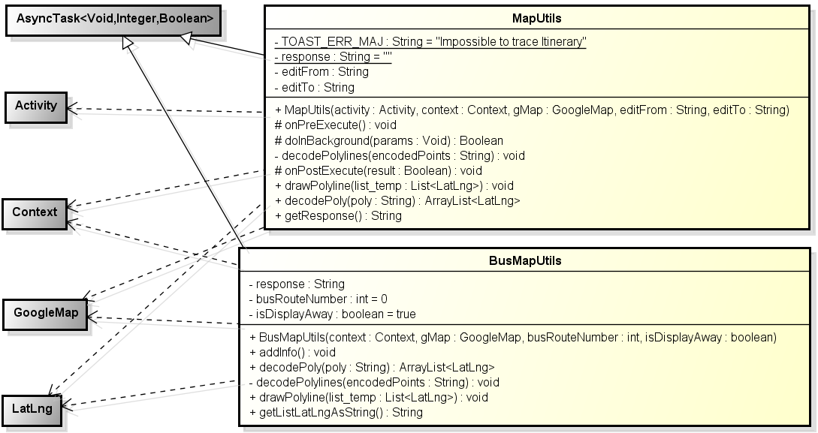

**Figure 5: Class diagram wsclient package**

|  |  |  |
| --- | --- | --- |
| No | Class Name | Description |
| 1 | BusMapUtils | Include method to work with bus map related services |
| 2 | MapUtils | Include method to work with map related services |

### BusMapUtils

#### Attributes

|  |  |  |  |  |  |
| --- | --- | --- | --- | --- | --- |
| No | Attribute | Type | Default | Note | Description |
| 1 | reminderList | Reminder[] |  | private |  |

#### Methods

|  |  |  |
| --- | --- | --- |
| No | Method | Description |
|  | getReminderList() | Interact with database: get reminder list |
|  | setReminder() | Interact with database: set a reminder (add/edit/delete/suspend) |
|  | showReminderList() | Notify change to view – show reminder list |
|  | showReminderDetail() | Notify change to view – show reminder detail |
|  | showReminderSetDone() | Notify change to view – show reminder set done |

### MapUtils

#### Attributes

|  |  |  |  |  |  |
| --- | --- | --- | --- | --- | --- |
| No | Attribute | Type | Default | Note | Description |

#### Methods

|  |  |  |
| --- | --- | --- |
| No | Method | Description |
|  | setReminder() | Set a reminder (add/edit/delete/suspend) |
|  | viewReminder() | View reminder list |
|  | viewReminderDetail() | View reminder detail |

### Sequence Diagram

#### UC0018_View bus reminder

#### UC0019_Add reminder

#### UC0020_Edit reminder

#### UC0021_Delete reminder

#### UC0022_Suspend/Unsuspend all reminder

#### UC0023_Suspend/Unsuspend a chosen reminder

# Functions

## Bus function group

### Class diagram

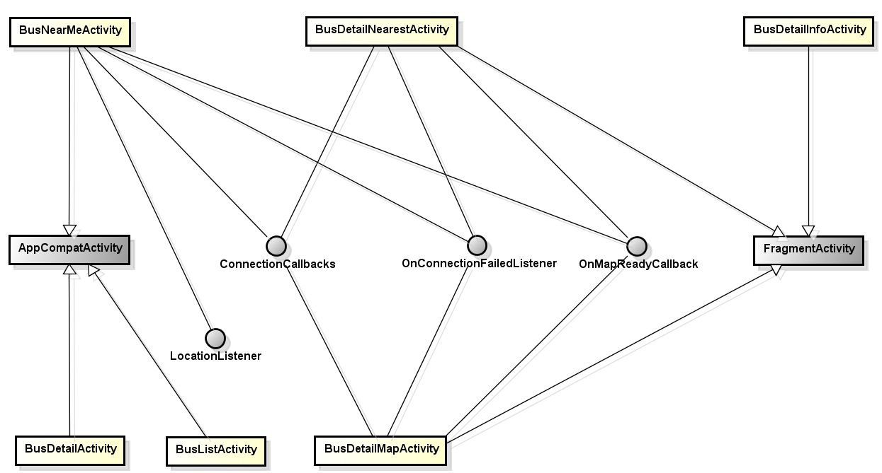

### Sequence diagram

## Path function group

### Class diagram

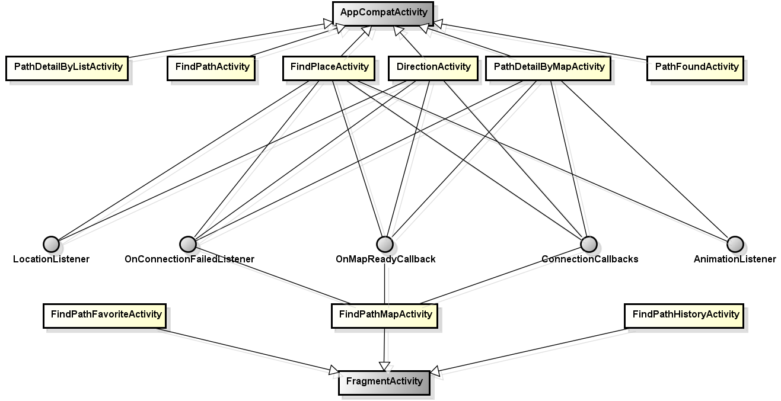

### Sequence diagram

## Favorites function group

### Class diagram

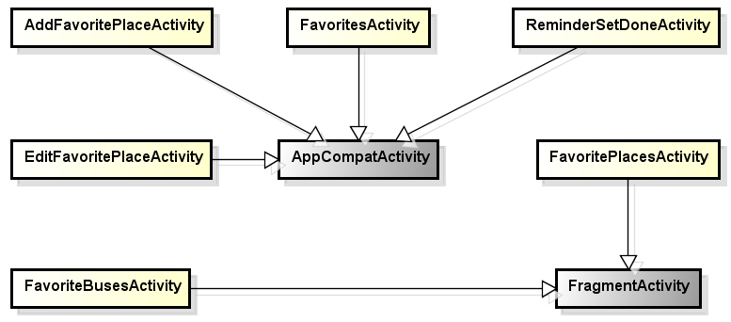

### Sequence diagram

## Reminder function group

### Class diagram

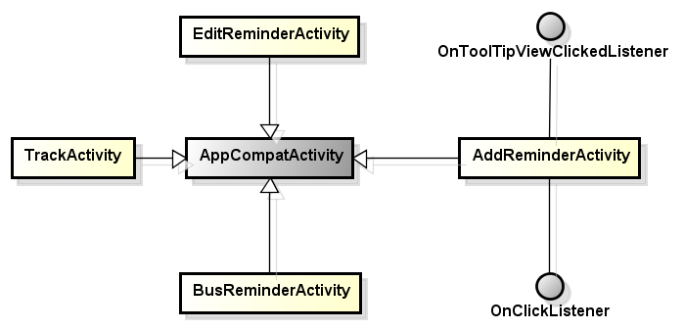

### Sequence diagram

## Other function

### Class diagram

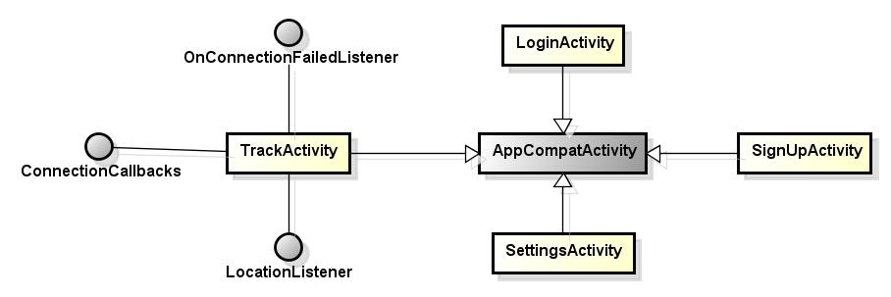

### Sequence diagram

# Layer architecture pattern

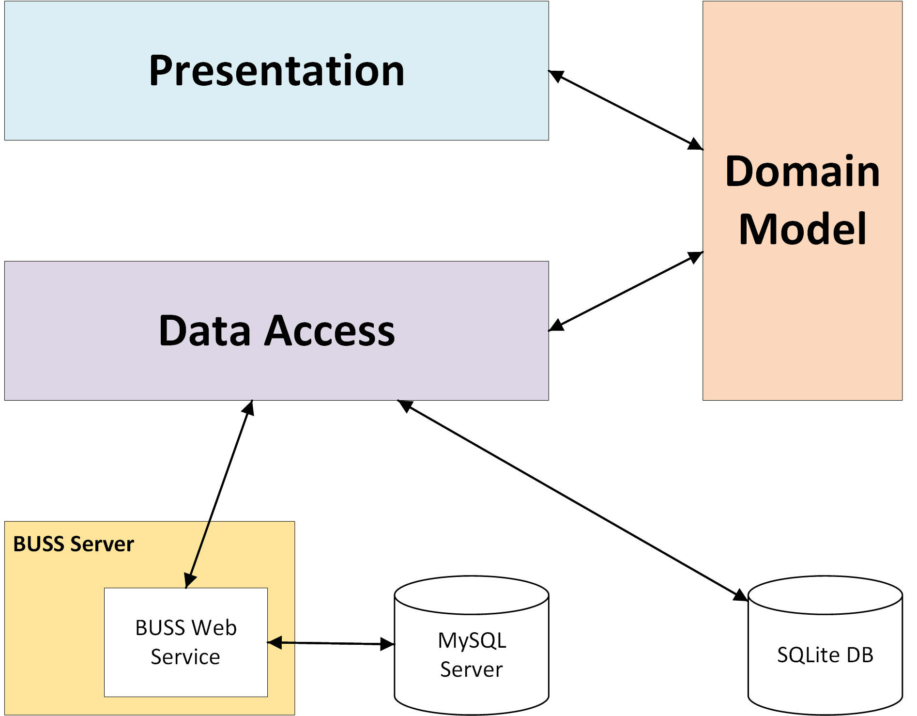

***Figure 6: Layer architecture pattern***